
Rhododendron Ornament

ORDER FORM

The cost for each ornament is $20.00. Ornament orders must be Mailed by Dec 1, 2025.

MAIL FORM AND CHECK(S) TO:

Carol Williams
128 Locust Ave
Spencer, WV 25276

Please Print

Club/District: _____________________________________________________________________________

NAME: _____________________________________________________________________________________

ADDRESS:__________________________________________________________________________________

City:__________________________________ STATE:_____ ZIP:______________

PHONE #:_______________________________ EMAIL:___________________________________________

QUANTIY: _________________TIMES $20.00 =$_______________________________________________
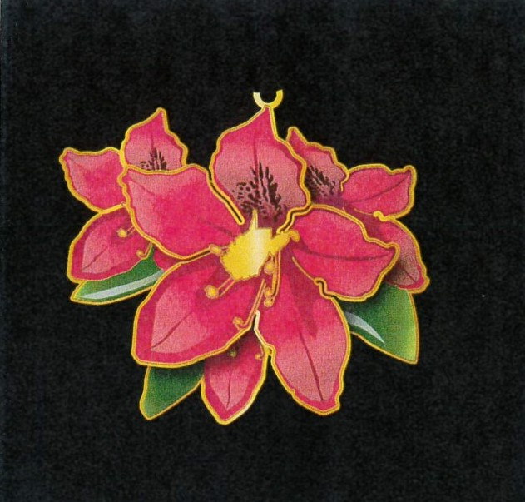
Figure 1 Approximately 3"x2.5"

